DUAL INPUT, UNBALANCED OUTPUT DIFFERENTIAL AMPLIFIER

The circuit shown below is a dual-input unbalanced-output differential amplifier. Here in this circuit , the two input signals (dual input), vin1 and vin2, are applied to the bases B1 and B2 of transistors Q1 and Q2.The output vo is measured C2.

Circuit Diagram:-

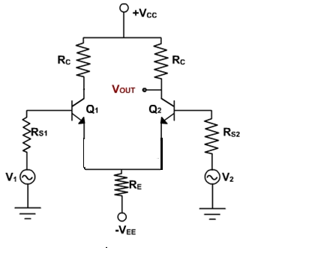

***AC Analysis***:-

To perform ac analysis to derive the expression for the voltage gains Ad and input resistance Ri of a differential amplifier:

1) Set the dc voltages +VCC and –VEE at 0

2) Substitute the small signal re equivalent models for the transistors

Figure below shows resulting ac equivalent circuit of the dual input unbalanced output differential amplifier



AC EQUIVALENT CIRCUIT FOR DUAL-INPUT BALANCED OUTPUT DIFFERETIAL AMPLIFIER

Writing Kirchhoff’s voltage equations for loops 1 and 2 gives us

vin1 – Rin1ib1 – reie1 – RE (ie1+ie2) = 0 (1)

vin2 – Rin2ib2 – reie2 – RE (ie1+ie2) = 0 (2)

Substituting current relations ib1 = ie1/β ac and ib2 = ie2/β ac yields

vin1 – Rin1 ie1/β ac – reie1 – RE (ie1+ie2) = 0 (3)

vin2 – Rin2 ie2/β ac – reie2 – RE (ie1+ie2) = 0 (4)

Generally, Rin1/β ac and Rin2/β ac values are very small therefore we shall neglect them here for simplicity and rearrange these equations as follows:

(re+RE) ie1 + REie2 = vin1 (5)

REie1 + (re+RE) ie2 = vin2 (6)

Eqns (5) and (6) can be solved simultaneously for ie1 and ie2 by using Cramer’s rule:

ie1=

ie2=

ie1 = [vin1 (re+RE)- vin2RE]/[ (re+RE)2-RE2] (7)

ie2 = [vin2 (re+RE)- vin1RE]/[ re (re+2RE)] (8)

The output voltage is

vo = vc2

= -RCic2 (9)

= – RCic2

=RC(– ie2) since ic = ie

Substituting current relations ie1 and ie2 in eqn(9), and Generally,RE>>re, which implies that (re+2RE) = 2RE and (re+RE) = RE.

we get

vo = = (RC/2re) (vin1 – vin2)

Thus a differential amplifier amplifies the difference between two input signals .By defining vid as the difference in input voltages, we can write the voltage-gain equation of the dual-input unbalanced-output differential amplifier as follows:

Ad = vo /vid = RC/2re  (10)

***Differential Input Resistance***:-

Differential input resistance is defined as the equivalent resistance that would be measured at either input terminal with the other terminal grounded.

Ri1 = |vin1/ib1|Vin2=0

=|vin/(ie1/βac)|Vin2=0

Substituting the value of ie1, we get

Ri1 = βacvin1/[{(re+RE)vin1 – RE(0)}/{(re+RE)2 – (RE)2}] (11)

=[βac(re2+2reRE)]/(re+RE)

=[βac re(re+2RE)]/(re+RE)

Generally,RE>>re, which implies that (re+2RE) = 2RE and (re+RE) = RE.

Therefore eqn(11) can be rewritten as

Ri1 = βacre(2RE)/RE = 2βacre (12)

Similarly, the input resistance Ri2 seen from the input signal source vin2 is defined as

Ri2 = |vin2/ib2|Vin1=0

=|vin2/(ie2/βac)|Vin1=0

Substituting the value of ie2 from eqn,we get

Ri2 = βacvin2/[{(re+RE)vin2 – RE(0)}/{(re+RE)2 – (RE)2}] (13)

=[βac(re2+2reRE)]/(re+RE)

=[βac re(re+2RE)]/(re+RE)

However, (re+2RE) =2RE and (re+RE) = RE if RE>>re. Therefore eqn(15) can be rewritten as

Ri2 = βacre(2RE)/RE = 2βacre (14)

***Output Resistance***:-

Output resistance is defined as the equivalent resistance that would be measured at either output terminal w.r.t ground.

Ro1 = Ro2 = RC (15)